United Nations Development Programme
Ministry of Labour and Social Welfare

Terms of Reference
Setting up SCS installations in Social Welfare Centres

Date: 29 January 2014

Authors: Srđan Kadić, Branimir Bukilić

Opinions expressed in this document are those of the authors and they do not necessarily reflect views of UNDP.

Table of Contents
1. List of used regulations, standards, norms 4
2. Technical requirements 6
2.1. General provisions 6
2.2. Laying cable installations 6
3. Special requirements 10
4. Repairs and upgrade of electrical wiring 12
4.1. Testing cables and measurements 12
5. Description of locations and special requests 19
5.1. SWC Podgorica – administration building 19
5.2. SWC Podgorica – Unit for Child Protection Services 19
5.3. SWC Podgorica – Regional unit Danilovgrad 20
5.4. SWC Cetinje 20
5.5. SWC Plav 20
5.6. SWC Bijelo Polje 21
5.7. SWC Bijelo Polje – Regional Unit Mojkovac 21
5.8. SWC Bijelo Polje – Regional unit Kolašin 22
5.9. SWC Berane 22
5.10. SWC Berane – Regional unit Andrijevica 22
5.11. SWC Rozaje 23
5.12. SWC Pljevlja 23
5.13. SWC Pljevlja – Regional unit Žabljak 23
5.14. SWC Bar – Regional unit Ulcinj 24
5.15. SWC Bar 24
5.16. SWC Nikšić 24
5.17. SWC Nikšić – Regional unit Šavnik 25
5.18. CSR Nikšić – Regional unit Plužine 25
5.19. SWC Kotor - Regional unit Budva 25
5.20. SWC Kotor 25
5.21. SWC Kotor - Regional unit Tivat 26
5.22. SWC Herceg Novi 26
5.23. List of locations 26

List of used regulations, standards, norms

The following technical regulations were used during project design development:
- The Fire Protection Law (Official Gazette of SRM 47/92 ),
- The Law on Health and Safety at Work (Official Gazette of SRM 35/98 ),
- The Law o Spatial Development and Construction of Structures (Official Gazette of Montenegro 51/08),
- The Rulebook on technical norms for law voltage electrical wiring (Official Gazette of SFRY 53/88)
- Yugoslav standards Electrical wiring in buildings - Safety requirements JUS N.B2.741/1989
- EN 50173-1 Information technology - Generic cabling systems - Part 1: General requirements
- EN 50173-2 Information technology - Generic cabling systems - Part 2: Office premises
- EN 50173-3 Information technology - Generic cabling systems - Part 3: Industrial premises
- EN 50173-4 Information technology - Generic cabling systems - Part 4: Homes
- EN 50173-5 Information technology - Generic cabling systems - Part 5: Data centres
- EN 50174-1 lnformation technology - Cabling installation - Part 1: Installation specification and quality assurance
- EN 50174-2 Information technology - Cabling installation - Part 2: Installation planning and practices inside buildings
- EN 50174-3 Information technology - Cabling installation Part 3: Installation planning and practices outside buildings
- EN 60728-1 Cable networks for television signals, sound signals and interactive services - Part 1: System performance of forward paths
- EN 50117-2-4 Coaxial cables- Part 2: Sectional specification for cables used in cabled distribution networks- lndoor drop cables for systems operating at 5 MHz - 3 000 MHz.
- EN 50117-2-3 Coaxial cables used in cabled distribution networks. - Part 4: Sectiona1 specification for distribution and trunk cables
- EN 50117-2-5 Coaxial cables used in cabled distribution networks - Part 2-5: Sectional specification for outdoor drop cables for systems operating at 5 MHz - 3000 MHz
- EN 50290-2-1 Communication cables -- Part 2-1: Common design rules and construction
- EN 50310 Application of equipotential bonding and earthing in buildings with information technology equipment
- EN 50346 Information technology - Cabling installation - Testing of installed cabling
- EN 50441-1 Unscreened cables for indoor residential telecommunication installations - Part 1: class 1 EN 50441-2 Screened cables for indoor residential telecommunication installations –Part 2: class 2
- EN 50441-3 Screened cables for indoor residential telecommunication installations – Part 3: class 3
- EN 60603-7-3 Connectors for electronic equipment - Part 7-3: Detail specification for 8- way, shielded, free and fixed connectors, for data transmissions with frequencies up to100MHz (currently under preparation)
- EN 60603-7-5 Connectors for electronic equipment: - Part 7-5: Detail specification for 8-way, shielded, free and fixed connectors, for data transmissions with frequencies up to 250 MHz (currently under preparation)
- EN 60603-7-7 Connectors for electronic equipment: - Part 7-7:Detail specification for 8-- way, shielded, free and fixed connectors, for data transmissions with frequencies up to 600 MHz (category 7, shielded)
- EN 60966-2-4 Radiofrequency and coaxial cable assemblies - Part 2-4: Detail specification for cable assemblies for radio and TV receivers (Frequency range Oto 3 000 MHz, IEC 61169-2 connectors).
- EN 60966-2-5 Radiofrequency and coaxial cable assemblies - Part 2-5: Detail specification for cable assemblies for radio and TV receivers (Frequency range Oto 1 000 MHz, IEC 61169-2 connectors).
- EN 60966-2-6 Radiofrequency and coaxial cable assemblies - Part 2-6: Detail specification for cable assemblies for radio and TV receivers (Frequency range Oto 3 000 MHz, IEC 60169-24 connectors).
- EN 61169-2 Radiofrequency connectors - Part 2: Sectiona1 specification - Radiofrequency coaxial connectors of type 9.52 EN 61169-24 Radiofrequency connectors - Part 24: Sectional specification - Radiofrequency coaxial connectors with screw coupling, typically for use in 75 ohm cable distribution systems (type F).
- EN 50083 Cabled distribution systems for television, sound and interactive multimedia signals
- EN 50083-1 Safety requirements.
- EN 50083-2 EMC for equipment.
- EN 50083-3 Active wideband equipment;
- EN 50083-4 Passive wideband equipment;
- EN 50083-5 Headend equipment;
- EN 50083-6 Optical equipment;
- EN 50083-7 System performance.
- EN 50083-8 EMC for networks.
- EN 50083-9 Interface for DVBIMPEG2 transport stream.
- EN 50083-10 System performance for return path.

Technical requirements

These requirements are an integral part of the project design and, as such, are binding for both the Investor and the Contractor, who have to comply with them when setting up designed installations, as they include elements not mentioned in the technical description and other annexes but still are important for carrying out works. Therefore, the following should be observed when setting up designed installations:

General provisions
- All electrical wirings should be laid in line with attached plans, cost estimate, technical description, Rulebook on technical norms for low voltage electrical wiring (The Official Gazette 53/88), appropriate JUS standard and attached technical requirements.
- Before works start, the Contractor must familiarize themselves in detail with the project design and submit their remarks, if any, to the Investor, i.e. supervising authority in a timely manner.
- The Investor must ensure expert supervision of works during project implementation.
- If, in the course of implementation, there is a justified need for deviation or for small changes to the project design, the Contractor must obtain Investor's approval for each such deviation or change.
- The manner of setting up installations is provided in a separate description (next text).
- All installation materials and equipment to be used for setting up these installations have to conform to standards.
- Upon completing works, the Contractor is required to provide data to the Investor on all changes made in relation to this specification.
- All items from the Bill of Quantities imply delivery and full installation of equipment with necessary components and assembling tools and commissioning.
- Upon completing works, the Contractor must check functionality and quality of works in line with art. 189-198 of the Rulebook on norms for low voltage electrical wiring and provide appropriate certificates to the Investor.

Laying cable installations

General requirements for UTP cabling

  - These technical requirements are a basis for setting up a LAN network, and consequently the Contractor must comply with them while carrying out works.
  - All works must be completed in a quality manner and in line with related specification, international standards and norms of equipment manufacturer, i.e. the entire installation must be set up in line with the international standard ISO/IEC 11801, and according to technical description, drawings, and specifications of equipment and materials.
  - Upon delivering equipment and materials at social welfare centres' premises, an Investor's representative is required to perform a visual check of delivered equipment and record its condition in the works book.
  - In the course of works, necessary changes to the related specification are approved by Investor's authorised representative.
  - The supervising authority should record installation assembly and testing, as well as all any changes, in the works book.
  - The Contractor must eliminate anything that proves to be of insufficient quality during works or afterwards, at their own expense.
  - The Contractor must carefully read related specification so as to avoid any potential disagreements and misunderstandings and, if there are any differences between the project design and existing condition of buildings, suggest modifications to the project design.
  - Upon installation of devices and cable system, the facilities maintenance service will carry out periodical (daily, weekly, monthly) checks and tests of installed equipment, and record findings and remarks in a control book. These periodical checks and tests are important for maintaining high degree of structured cabling system availability.

Special requirements for UTP cabling

- Before works start, the Contractor must accurately determine and mark positions of all designed system's elements (sockets, distribution cabinets, active equipment, cable ducts, etc.)
- The Contractor should specify points where designed installations are connected to existing installations, as well as define and install connections for electrical wiring.
- Category 6 cables or higher by ISO/IEC standard, certified to work at 450MHz, must be used for cabling computer networks.
- Global network structure is of star type (multiple star). Each connection is of point-point type.
- Every point where several UTP cables meet is called a communication hub. There can be a communication hub that is central for an entire network, central for one location, central for one building or local.
- Active network equipment is installed in a communication hub and patch panels in a distribution cabinet of an appropriate size.
- Communication hubs are put in office-type rooms (proposal for locations is given in the ground plan).
- All RACK cabinets are closed (with opening only for inserting cables and for ventilation), and have glass door that can be locked.
- Some reinforcement and openings should be made for RACK cabinets to be mounted and fixed. Fixing on walls should be done with appropriate anchors and screws.
- UTP cables end in a panel or a socket.
- UTP cables cannot be cut and joined again.
- UTP cable is pulled through ducts or fixed with OG clamps to the wall at 30-50 cm distance or pulled through corrugated hose built into a wall.
- Routes proposed for laying UTP cables are presented in the ground plans included in attachment 1.
- Covers should be put on cable ducts in their full length, once cables are pulled through.
- While pulling it through and fixing it, UTP cable should not be twisted lengthwise, tied into a knot, broken or damaged in any other way.
- UTP cable must not be stretched while pulled through.
- UTP cable is laid vertically and horizontally. Angled UTP cabling is not allowed.
- Potential damage to cables must be seriously taken into account while cabling. In places where cable routes change direction, cables must be bent in slight curves, the radius of which must not be smaller than eightfold external diameter of the cable.
- UTP cable must not be placed near devices, structures or sources that may damage it.
- UTP cable must not be laid and pulled through near heat sources (heating systems, radiators, stoves or electric heaters), and if this cannot be avoided, appropriate heat insulation should be used.
- Outside a structure, UTP cable is laid in a one-piece PE hose, whose ends inside the structure are protected from atmospherics.
- RJ sockets are mounted 20- 40 cm above the floor.
- 10 cm of spare cable must be left on the side of each RJ socket, and 30-100 cm on the side of a patch panel, depending on where the patch panel is installed (inside a wall case or a RACK cabinet).
- Each cable must be marked with the same number (using stickers) immediately upon pulling it through.
- Cable numbers must match socket numbers, so that numbers increase clockwise, when viewed from a room's entrance door.
- Once UTP cables are pulled through, they must be tested for breaks and short-circuits. All acceptable cables must end with a socket or in a patch panel, in line with appropriate documentation.
- If there is a break or a short-circuit, the cable should be pulled out and replaced with a new one.
- Mounting of RJ socket and patch panels must be completed with professional tools.
- Performance of each line must be tested once mounting of sockets and patch panels is completed.
- Patch cables of appropriate length are used for connecting wall sockets and terminal equipment, i.e. patch panels and active equipment.
- Cabling that is parallel with power supply cables must be done with a minimum of 20 cm distance.
- Crossing of FTP cables with power supply cables must be done at a 90° angle.

Final provisions

- Upon completing all works, the Contractor must inspect, check and test the entire cabling system.
- The Contractor must complete all repairs before officially delivering the designed system to the Investor for utilization and handling.
- Quality inspection of completed works and functional testing and measurements are done by the Commission for quality inspection set up by the Investor, once the Contractor completes his final tests and checks.
- The contractor is not liable for breakdowns resulting from incompetent handling of devices and installations.
- User must ensure repair services and maintenance for the entire network once the warranty period expires.
- On all matters not included in these technical conditions, the Contractor must act in accordance with existing regulations.

Special requirements

Topology of the network to be set up in social welfare centres is of the "star" type, which means that UTP cables from each workplace are brought to the central RACK cabinet, i.e. telecommunication concentrator.
The concentration must be set up to allow any provider to make their TC services available to each workplace, after installation of appropriate equipment and via central RACK cabinet.
The structured cabling system for offices of social welfare centres is planned to have appropriate number of RJ 45 sockets connected to patch panels in a RACK cabinet in positions selected in relation to the proposal provided in ground plans (see ground plan for each of the centres as well as the table with a bill of quantities).
Ethernet cables in the RACK cabinet are connected to 24-port patch panels (or bigger or smaller or combination of several panels, depending on the number of connections).
Two (or more, if required in the ground plan) UTP cables Cat 6 are laid from the RACK cabinet to each workplace, of which:
- The first cable is used to give users Ethernet connection with centre's local computer network;
- The second cable is used to allow users to connect to existing Telecom infrastructure, i.e. to ensure services of the existing landline telephony (analogue telephone exchange), DSL connection, then connection to the future IP telephony system, etc. in a standard way.
Special attention should be paid to selection of area where a RACK cabinet is to be installed with the aim of having a rational solution, taking into account that the distance between the RACK cabinet and most remote RJ socket does not exceed the critical length of 90 m.
Since it is not possible to provide an appropriate room, RACK cabinets will be mounted on walls in one of the rooms that was selected following suggestions from the enclosed ground plan. Corridors and areas accessible to third persons should be avoided for positioning RACK cabinets, but if that is not possible then the option of locking RACK cabinets should be ensured. Power supply for RACK cabinets will be brought directly from RO cabinets, where they will be connected to a separate fuse.
Cables are laid in plastic ducts of appropriate size in relation to the number of cables used in a specific route. Cables are laid on walls, 30-50 cm above the floor, depending on space configuration and in agreement with a responsible person from each centre. Duct joints are concealed with covers that must be produced by the same manufacturer as ducts being used. Duct joint covers can be flat, T-shaped, for 90⁰ angles, for switching from a smaller duct to a bigger, etc. End of a duct must be closed with a cap, if the duct does not end where the wall ends. The ducts should be arranged so that corridors are used for the main route from which branches lead to separate offices. Exceptionally, if for justified reasons, ducts can also be arranged differently.
Ground plans from annex 1 include proposed routes. If there is a deviation from proposed routes due to justified reasons, the Investor's approval is required.
It should be ensured that incoming telecommunication lines, through which each facility is connected to the telecommunication network, end in the RACK cabinet and patch panel and that from there they are used for additional services (PSTN telephony, ADSL, Point To Point broadband connection, etc.)
Once works are completed and measurements are successful, existing phones need to be connected to the incoming phone line or telephone exchange through new SCS installation. Standard four-wire PSTN cable will be used for this purpose.

Repairs and upgrade of electrical wiring

The project of setting up SCS installations in centres also requires changes in high voltage electrical wiring, which include:
- Ensuring that RACK cabinet is supplied directly from RO cabinet that supplies SWC's offices, with a connection to a separate fuse in the cabinet.
- Repairing broken power supply sockets, by replacing them with new ones and fixing causes of defects, whether in a socket itself or in the RO cabinet.
- Laying new cables and connecting new sockets in places where that is required by description of works and the ground plan from annex 1.
- Moving sockets from their current position to workplace position with a set: plug + 3 power sockets, wherever there are no sockets close to a workplace.
Laying new, high voltage cables is also carried out with plastic ducts along walls, and cables end in wall-mounted boxes with 3 sockets each.
Since some of the centres already have SCS installations that are either damaged or of insufficient capacity, it is necessary to repair all damaged segments of existing SCS installations and upgrade them to meet required standards set for new installations by this document. Repair of existing SCS installations includes replacement of broken and faulty RJ sockets with new sockets specified by this document, as well as installation or repair of patch panels, if actual situation requires it. Addition of new RJ connection points, i.e. laying new UTP cables will be carried out in the manner defined by related document.
Before works start, the Contractor will first inspect each location, existing SCS installations (if any), as well as high voltage electrical wiring, and draft a specifications of repairs. The specification of repairs is approved by the Investor.

Testing cables and measurements
Segment length must conform to the IEEE 802.3u 100 Base-TX standard of 100 meters per segment, by using 22 AWG UTP cable. After cabling, it is necessary to measure the real length of a laid cable. This length should not be greater than 90 meters between a patch panel and sockets in offices (due to attenuation caused by connectors).
It is also necessary to check whether pairs in connectors are evenly distributed. Standards that must be met are ISO/IEC 11801 class E.
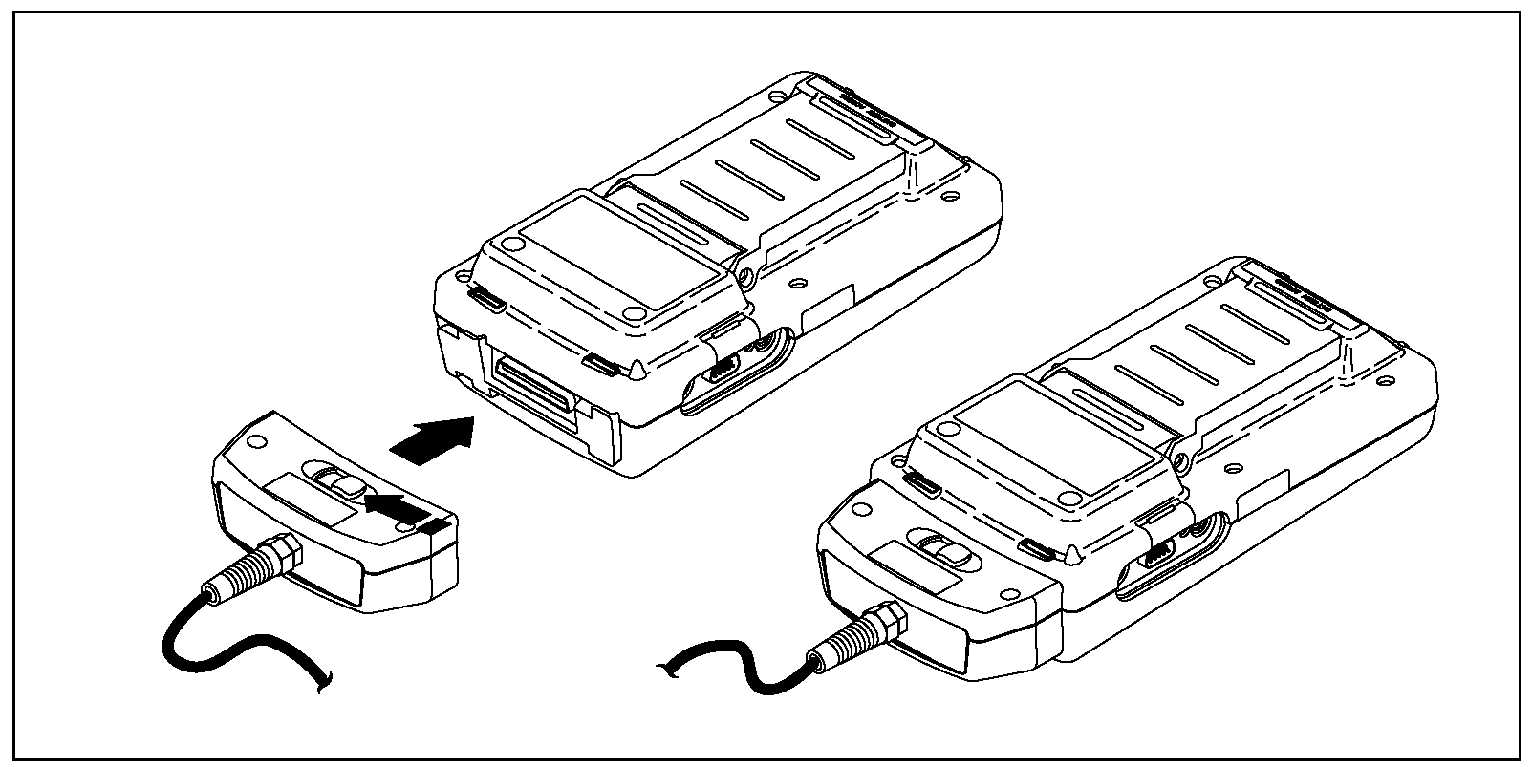

The check is carried out with a device for testing and measuring performance of a cable with twisted pairs in local networks. It consists of two units placed on opposite ends of a cable that communicate with each other. The main unit initiates all tests, while distant one closes loops, gathers and sends results of each measurement.

Both units are synchronised and all tests are performed automatically.

Testing and measuring UTP cables
- TIA TSB 67 standard

Applications using 100Mbps or greater data transfer speeds set some major requirements for cable systems when it comes to their performance. The only way to ensure the cable system will support those high data transfer speeds is to check whether performance of installed cabling match "Category 5" standard. EIA/TIA-568 standard specifies performance of cable system elements (cable, connectors, patch cable), but the standard does not specify required performance of a cable system.

Due to aforementioned reasons, TIA formed a team in 1993 tasked to formulate UTP link testing standard. Result of their work was TSB-67 (Transmission Performance Specifications for Field Testing of Unshielded Twisted-Pair Cabling Systems) standard. This standard was published in October 1995 and it defines how installed cabling should be tested, specifies performances of cable systems as well as the minimum accuracy of measuring instruments.
There are four parameters of UTP cable that should be checked, according to this standard:
- Connection reliability (wire map)
- Length
- Weakening per pair (Attenuation)
- Crosstalk level (NEXT - Near End Crosstalk)

Maximum length, attenuation and crosstalk for two configurations are specified by TSB-67 standard : Basic link configuration and Channel configuration

Basic link test and Channel test

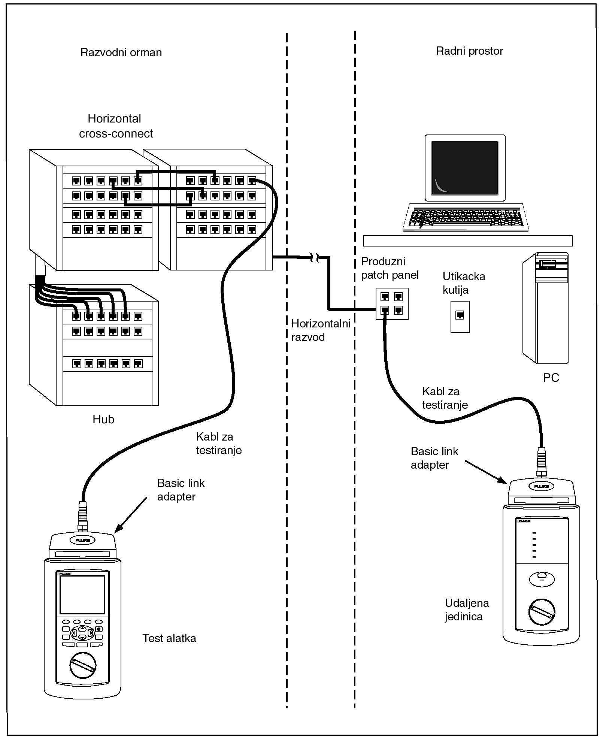
Translation: distribution board, horizontal cross-connect, hub, testing cable, basic link adapter, test tool; Horizontal distribution; Workplace, extension patch panel, socket, PC, testing cable, basic link adapter, remote unit.

Channel test configuration covers entire link from one end to another, including patch cables on both ends.
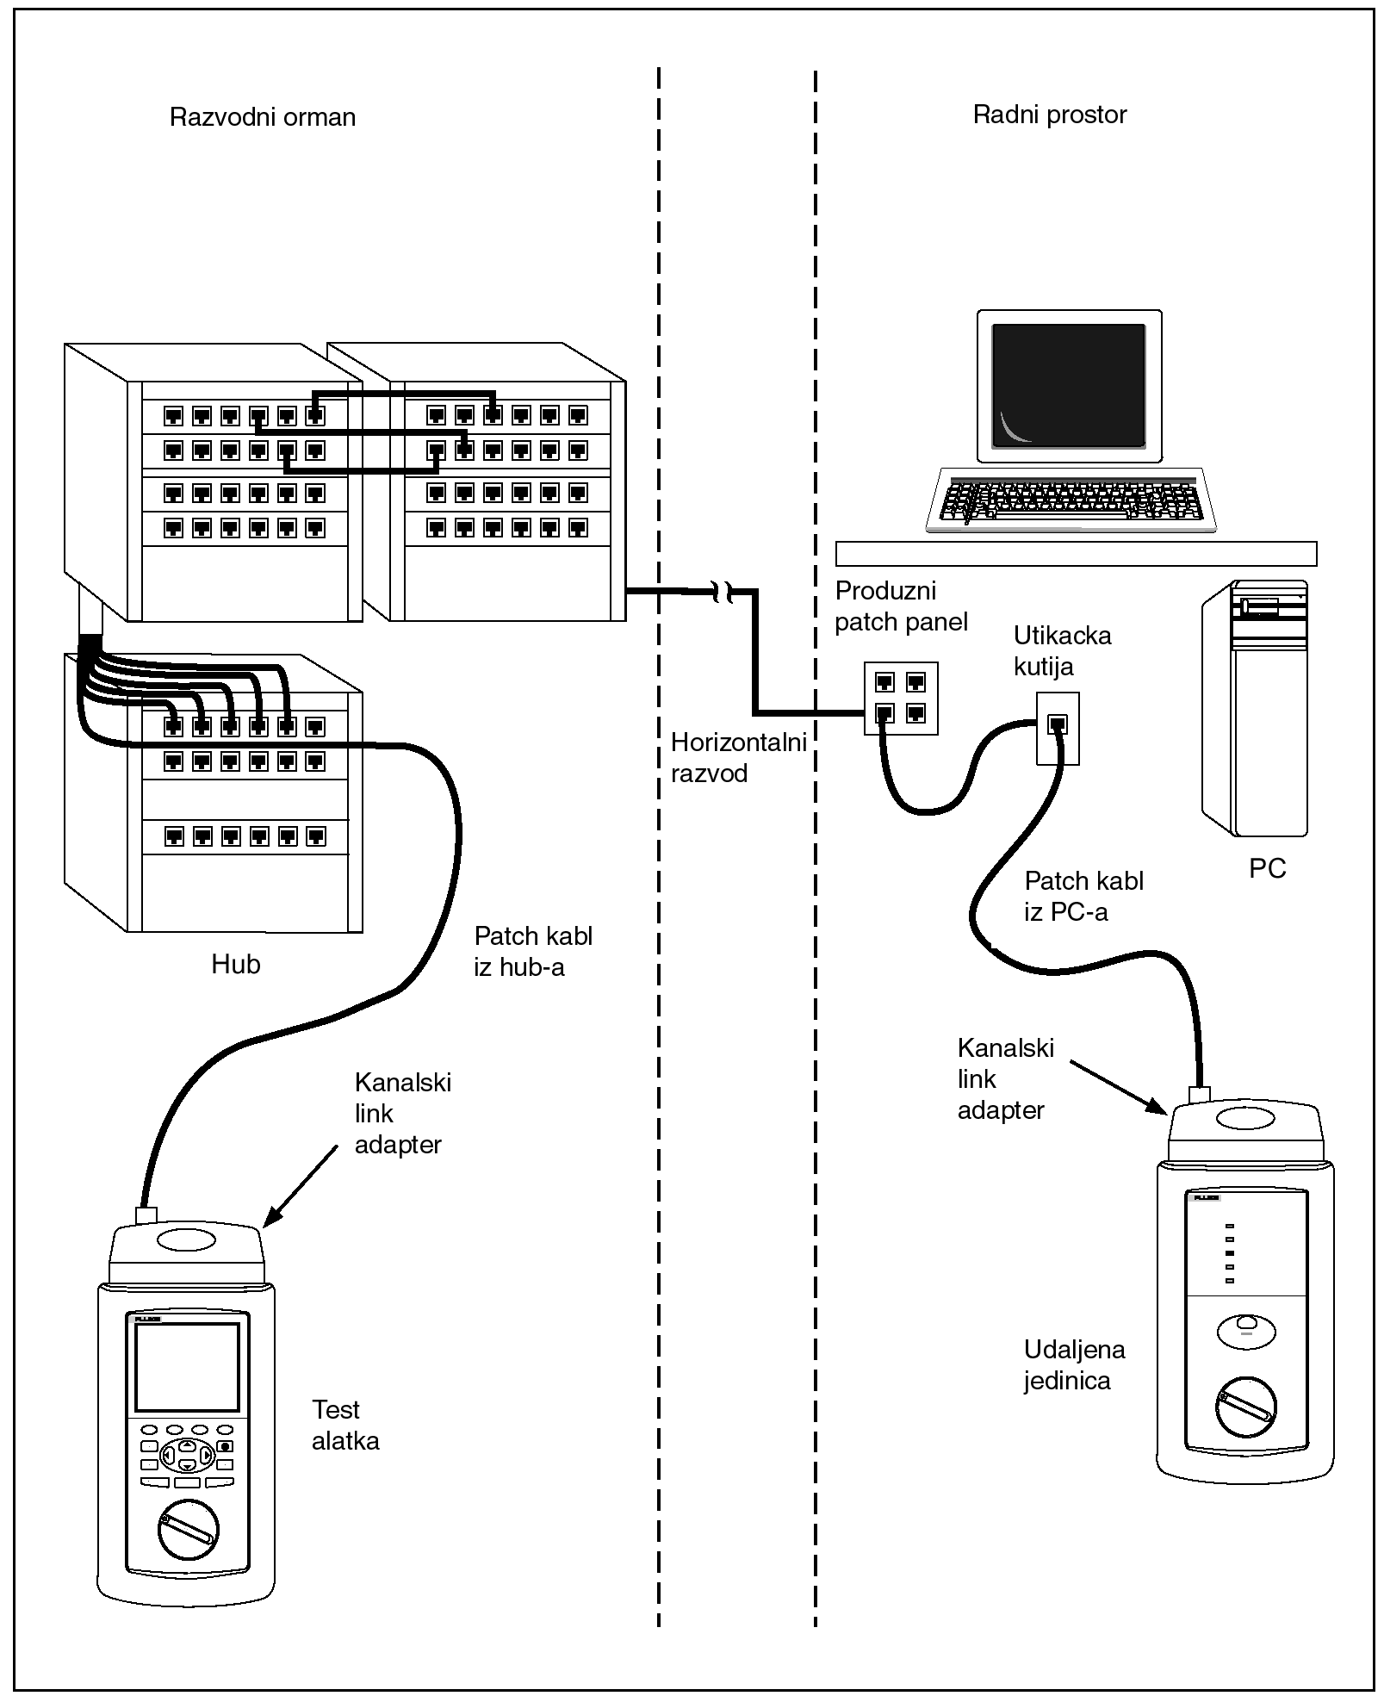
Translation: distribution board, hub, patch cable from the hub, channel link adapter, test tool; Horizontal distribution; Workplace, extension patch panel, socket, PC, patch cable from the PC channel link adapter, remote unit.

Basic link test configuration includes part of the link from the wall socket to the patch panel.

Wire Map test
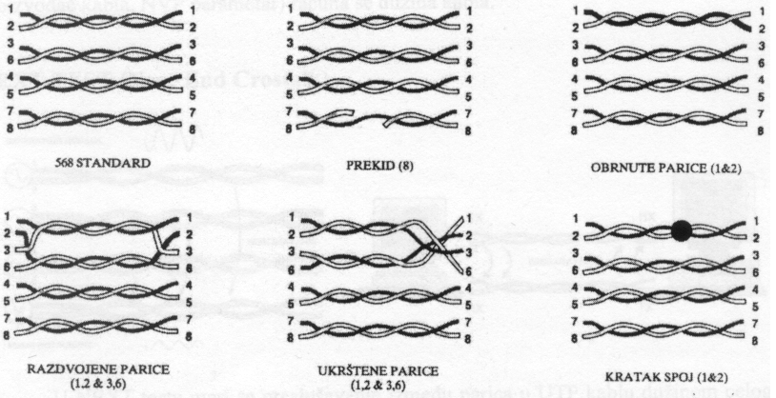

Translation: standard, break, reversed pair, split pair, crossed pair, and short-circuit

Wire map test checks whether wire distribution along the entire link corresponds to the standard. This test also checks whether there are any of the following faults: break, short-circuit, crossed pair, reversed pair and split pair.

- Length of all pairs in the connection

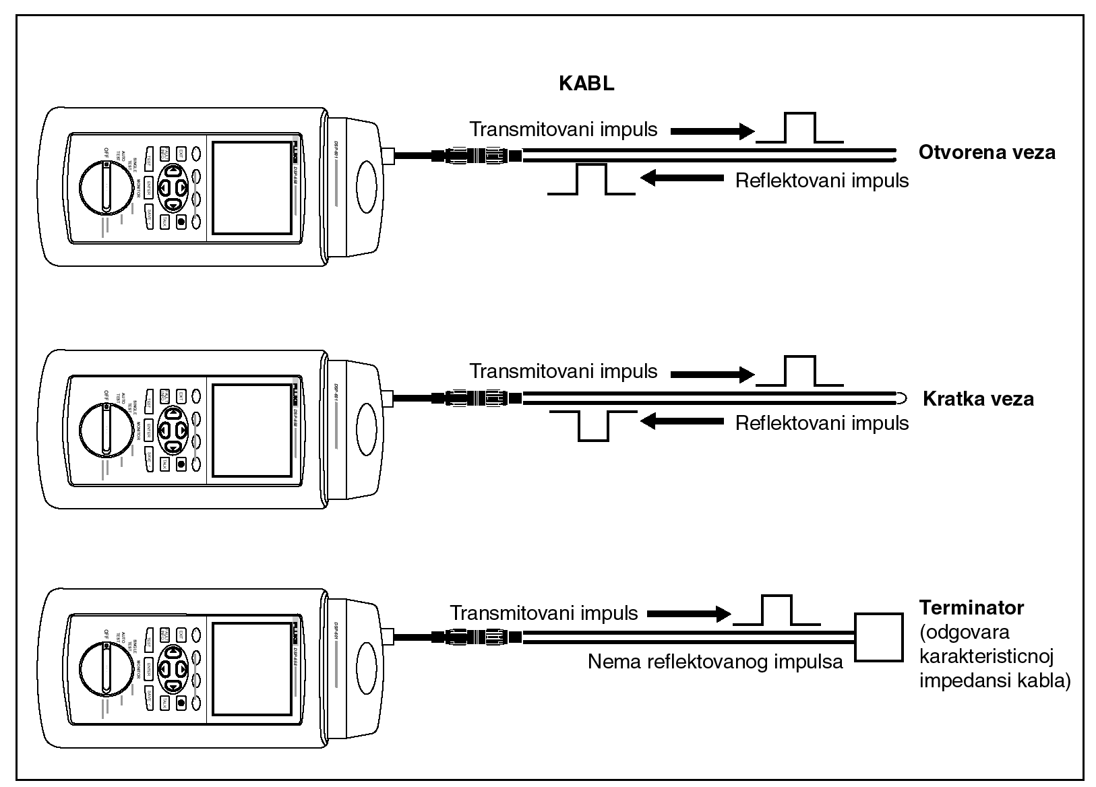
Most network types have characteristic maximum segment lengths that ensure proper functioning of the network.
Translation: Cable, transmitted impulse, open connection, reflected impulse; Transmitted impulse, short connection, reflected impulse; Transmitted impulse, terminator (corresponds to typical impedance of the cable), no reflected impulse.

Length test is therefore very important for network functioning. Cable length is measured in the following way: timer is turned on at the same moment when signal is transmitted, the signal travels through the cable until it reaches a point where impedance changes (break, short-circuit, damage on the cable) where the entire signal or a part of it is reflected back. When the reflected signal reaches the measuring instrument, the timer is stopped.
Cable length is calculated by using the time measured by the timer and known speed at which the signal travels through the cable (provide by cable manufacturer, NVP parameter).

- Weakening per pair (Attenuation)

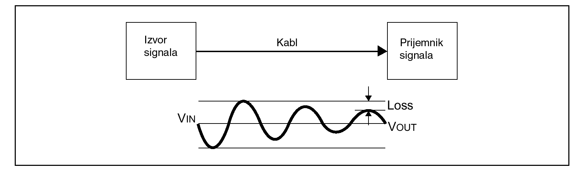
Translation: signal source, cable, signal receiver

Attenuation test measures signal attenuation (weakening) along a link. Attenuation is measured at a frequency range and is measured in decibels (dB). Attenuation varies depending on the cable length and frequency. Attenuation increases with greater length and higher frequency. Causes of significant attenuation usually include: low quality patch cable, poor cable termination (connector, module in patch panel), excessive length, and components that do not meet the standard.

- Cross talk level (NEXT)

NEXT TEST (Near End Crosstalk)

NEXT test measures crosstalk between pairs in a UTP cable along an entire link. NEXT is measured in decibels (dB). High value in dB, which is usually referred to as NEXT, is desirable (48dB, for example), because it means that there is a big difference between the sent signal and the resulting NEXT. Small DB value (20dB, for example) is known as big NEXT and it means that there is a significant crosstalk between the pair through which the signal travels and other pairs.

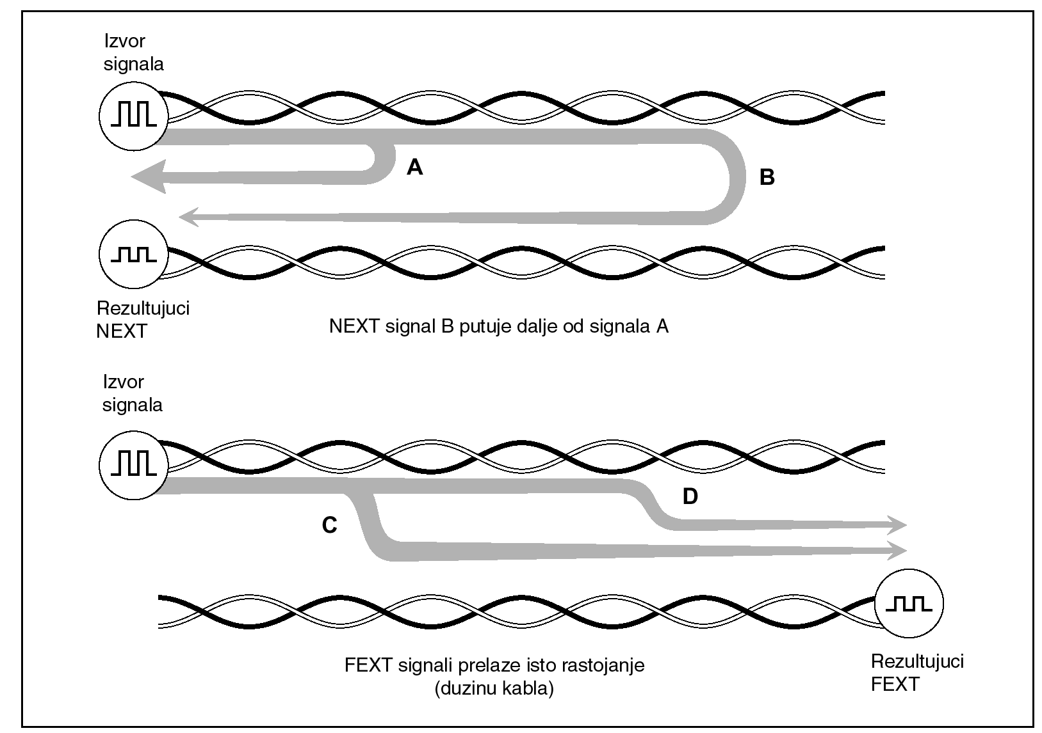
Translation: Signal source; Resulting NEXT, NEXT signal B travels farther than signal A; Signal source, FEXT signals travel the same distance (length of cable), resulting FEXT

Usual causes of big NEXT include: poor quality patch cable, poor cable termination (connector, module in patch panel), split pair, components that do not meet the standard.

- ISO/IEC 11801-2000

In addition to above mentioned tests, this test specifies additionally tests for:
- DC resistance
- Impedance
- ACR value for all pairs (ratio of attenuation/crosstalk)

The check is performed with a device for testing and measuring performance of twisted-pair cables in local networks. It consists of two units placed at the opposite ends of a cable that communicate with each other. The main unit initiates all tests, while the remote one closes loops, gathers and sends results of each measurement. Both units are synchronised and all tests are performed automatically.

The above mentioned device can:
- Measure and test cable characteristics in relation to a specific standard
- Test open, crossed or split pairs
- Measure crosstalk at a near end (NEXT test)
- Measure length of twisted pairs in meters
- Measure delays due to propagation
- Measure impedance of each cable pair
- Measure resistance on a cable
- Measure resistance of each pair
- Measure attenuation coefficient for all combinations of cable pairs
- Measure signal losses through a cable and locations of resistance points on a cable
- Locate crosstalk point in a cable
- Draw NEXT curve and ACR level of attenuation/crosstalk

Important: SCS testing is performed on both new and existing installations. In case the test of existing installations identifies malfunctions, the Contractor must report it to the Investor and repair that segment of the installation.

Description of locations and special requests

SWC Podgorica – administration building
SWC Podgorica administration building does not have a quality SCS installation, which means that the focus of this project is to set up SCS installations in the entire building according to the enclosed building ground plan. SCS installation should be placed along routes agreed on the spot when works start, but it is suggested to use plastic ducts of appropriate dimensions to lay routes, which will go along corridors and from there branch into offices. Proposed routes are marked with blue in the building's ground plan.
Setting up SCS installations needs to ensure that each workplace has at least two RJ45 sockets and that their positions are accessible from the position of desks. Depending on the position of desks in relation to the wall, onto which RJ45 sockets will be mounted, and if necessary, floor ducts should be laid to ensure physical protection of patch cables that will connect computers and telephones to the SCS installation.
The best position for the RACK cabinet is inside doorman's booth on the ground floor, next to the entrance (marked on the ground plan).
In addition to setting up SCS installations, power supply sockets should be repaired, wherever it is deemed necessary. The repair will include replacement of power supply sockets (a double socket is always mounted), fuse replacement or any other way approved by the purchaser.

SWC Podgorica – Unit for Child Protection Services
Unit for Child protection services is located in the premises with six offices in it. The premises do not have SCS installations; therefore the subject of this project is setting up the SCS installations as per attached ground plan. SCS installations should be installed on the routes identified on the beginning of the construction works, however the map of routes as well as RACK positions are indicated in the ground plan.
Besides the setting up of SCS installations, schuko power sockets should be repaired wherever it is necessary. The adaptation works requires the replacement of existing schuko power sockets (double schuko power sockets should be placed), replacement of circuits, or alternatively adaptation works should be done in a way suggested by the Investor. Also, it is mandatory to relocate schuko power sockets in a surface-mounted sequence with three connectors wherever the connection is physically far from the working desk.

SWC Podgorica – Regional unit Danilovgrad
Regional unit Danilovgrad is located in Tax Administration's premises. It has two offices with 4 workrooms. Those rooms, as well as electrical wiring are in very poor condition. There is no computer network and computers are not connected to the Internet.
Regional unit Danilovgrad does not have any SCS installations. Setting up of SCS installations, based on the enclosed ground plan, is necessary.
In addition to setting up and adapting SCS installations, damaged power supply sockets should also be replaced, wherever it is deemed necessary.

SWC Cetinje
Offices of Cetinje regional unit are located in the Historical Capital Cetinje building. The regional unit has 3 offices, of which 2 are adjacent one to another and the third one is 18m away, in the same corridor.
Focus of the project in these premises is setting up of SCS installation based on the enclosed ground plan, as well as electrical wiring modifications in the office marked with number 3 in the ground plan.
The RACK cabinet should be placed in office 1, above a cupboard, or somewhere else with purchaser's approval.
The telephone exchange must be moved to BD rack cabinet and all analogue telephones must be connected to the new telephone exchange via new SCS installation.
The ceiling in all offices is at 3.5 m above the floor.
Modifications of electrical wiring in office 3 include:
- Distribution of new lines in wall-mounted plastic ducts, in two positions inside the office and taken from the junction box, which is in the office.
- Installation of a triple power supply socket at the end of each line.

SWC Plav
There is already a SCS installation in all offices of Plav SWC. Although RJ45 positions and sockets do not go with desk arrangements, adding new ones or changing their position is not necessary.
As SWC shares the same building with the Employment Office and Pension and Insurance Fund, the central rack concentrator is currently a shared one for all three institutions. Although LAN in SWC is not set up in a quality manner, there are already obscurities in the RACK cabinet that could result in problems for system maintenance or undermine the security of information. For that reason, in addition to existing BD, it is necessary to add (above, below, depending on the length of existing cables) another RACK cabinet where all RJ45 cables from sockets in SWC offices should be transferred, as well as incoming telecommunication links used by the Centre.

SWC Bijelo Polje
SWC's building in Bijelo Polje already has SCS installations that are partly used. The existing SCS installation is set up from two interconnected RACK cabinets on the ground and the first floor. The link that connects them should be checked and exact number of UTP cables physically laid between them should be identified. Minimum of 2 UTP cables are necessary for a proper connection between the two RACK cabinets. If that's not the case, a new installation, which would meet this requirement, must be added. The existing SCS installations are of insufficient capacity for all offices, given the planned number of employees, and therefore new cables should be laid and new RJ45 sockets installed in those offices. New cables can be laid in existing plastic ducts, where their capacity allows it. If not, a new plastic duct of sufficient capacity for new cables should be installed.
In addition to putting new RJ45 sockets, replacement of existing RJ45 sockets that are physically damaged is also necessary.
Besides setting up and modifying SCS installations, damaged power supply sockets should be replaced where deemed necessary.

SWC Bijelo Polje – Regional Unit Mojkovac
Mojkovac RU is located in a refurbished building that already has SCS installations. The offices are on the first floor, the ground floor (reception office).
As it is a building shared by several institutions, there is a RACK cabinet on the first floor that is a joint one for all offices on the first floor. Given the inclination to set up a secured infrastructure at acceptable costs, a new RACK cabinet should be delivered and installed right next to the existing one and cables laid to the Centre's offices should be moved to the separate, new RACK cabinet. The cables in the existing RACK cabinet do not end in the PATCH panel and they are marked, which will make the work of moving them easier. Incoming telecommunication line and existing equipment belonging to the Centre should also be moved into the new RACK cabinet.
The office on the ground floor, planned for receiving applications, does not have RJ45 sockets. Three RJ45 sockets should be mounted in this office and they must be connected to the RACK cabinet on the first floor, as suggested in the ground plan. Cables must be laid in plastic ducts along the corridor. Also, this office has only one power supply socket. Another line from RO cabinet with a triple wall-mounted power supply socket at its end is necessary in this room.
All cables must be connected to the patch panel in the new RACK and existing and new SCS installations must be tested.

SWC Bijelo Polje – Regional unit Kolašin
All offices of the regional unit in Kolašin are on the same floor and adjacent one to another.
Focus of the project in these premises is to set up SCS installations based on the enclosed ground plan, as well as modify electrical wiring.
Based on the ground plan, the RACK cabinet is to be positioned in office 3, or in some other place with the purchaser's approval.
Modifications to the electrical wiring include replacement of all power supply sockets and their repair, if the socket is malfunctioning and that malfunction is not caused by a break in the power supply cable (malfunction may be in the junction board or inside the socket).

SWC Berane
There is already an unused SCS installation for some offices in SWC Berane. The existing SCS installation can be used after some repairs, depending on the need in any of those offices. In this context, repairs imply replacement of RJ45 sockets, if they are damaged.
Also, extension of the existing SCS installation to offices currently not covered by any installation is necessary. Those are one office on the first floor, which is a meeting room, and offices in the building's attic. Suggested route for laying plastic ducts and points where concrete slabs separating two levels should be drilled can be seen on the enclosed ground plan.
In addition to SCS installations, the project also requires detailed inspection and repair of electrical wiring in all offices of the Centre. This implies replacement of all power supply sockets, functioning or not, and their repair if malfunctioning, which also includes potential fixes in the RO cabinet in the sense of replacing fuses, etc.

SWC Berane – Regional unit Andrijevica
Regional unit Andrijevica does not have any SCS installation. Therefore, it is necessary to set up a SCS installation, based on the enclosed ground plan.
It needs to be ensured that incoming telecommunication lines, through which the building is connected the telecommunication network, end in BD rack cabinet and patch panel and that from there they are used for additional services (PSTN telephony, ADSL, Point To Point broadband connection, etc.)
In addition to setting up and modifying SCS installations, replacement of damaged power supply sockets is also required, wherever it is deemed as necessary by the Centre's technical staff.

SWC Rozaje
SWC Rozaje is located in the same building as Employment Bureau and Pensioner and Disability Fund. Reception office is at the ground floor, while other offices are on the second and third floor. SWC Rozaje does not have any SCS installations; therefore the subject of this project is setting up the overall SCS installations.
It is necessary to provide that incoming telecommunication lines, through which the building is connected to telecommunication network, should end in BD rack cabinet on patch panel and from there to be used for other services (PSTN, ADSL, Point To Point broadband connection etc.).
In addition to setting up and modifying SCS installations, it is necessary to replace schuko connectors wherever the technician staff from the Center finds it mandatory. Also, it is mandatory to relocate schuko power sockets in a surface-mounted sequence with three connectors wherever the connection is physically far from the working desk.

SWC Pljevlja
The premises of Pljevlja SWC have recently been refurbished, but SCS installations have not been set up.
It is necessary to set up SCS installations for all offices, based on the enclosed ground plan.
It needs to be ensured that incoming telecommunication lines, through which the building is connected the telecommunication network, end in BD rack cabinet and patch panel and that from there they are used for additional services (PSTN telephony, ADSL, Point To Point broadband connection, etc.)

SWC Pljevlja – Regional unit Žabljak
Regional unit Žabljak does not have any SCS installation. Therefore, it is necessary to set up a SCS installation, based on the enclosed ground plan.
It needs to be ensured that incoming telecommunication lines, through which the building is connected the telecommunication network, end in BD rack cabinet and patch panel and that from there they are used for additional services (PSTN telephony, ADSL, Point To Point broadband connection, etc.)
In addition to setting up and modifying SCS installations, replacement of damaged power supply sockets is also required, wherever it is deemed as necessary by the Centre's technical staff.

SWC Bar – Regional unit Ulcinj
Regional unit in Ulcinj has 7 offices: 4 on the first floor and 3 on the ground floor. There is an ADSL connection in the manager's office, and offices on the same floor are connected to the Internet via this connection.
It is necessary to set up SCS installations for all offices, based on the enclosed ground plan.
It needs to be ensured that incoming telecommunication lines, through which the building is connected the telecommunication network, end in BD rack cabinet and patch panel and that from there they are used for additional services (PSTN telephony, ADSL, Point To Point broadband connection, etc.)
In addition to setting up and modifying SCS installations, replacement of damaged power supply sockets is also required, wherever it is deemed as necessary by the Centre's technical staff.

SWC Bar
SWC Bar has 11 offices on the ground floor of a building which it shares with the Pension and Insurance Fund. SWC's building in Bar already has SCS installation that is used. The current SCS installation is set up with one RACK cabinet on the ground floor. The existing SCS installation is of insufficient capacity for all offices given the planned number of employees, and therefore installation of new cables and new RJ45 sockets is necessary in those offices. In addition to installation of new RJ45 sockets, replacement of existing, physically damaged RJ45 sockets is also necessary.
Once the works on expanding SCS installations are complete, it is necessary to measure and test all links, both existing and new ones and, based on results obtained, bring all links to the level that allows data transfer speed of 1Gbps.
When all the work is done, all RJ 45 sockets, both existing and new ones, must be uniformly marked based on rules from chapter 1 of the Network Topology.
In addition to setting up and modifying SCS installations, replacement of damaged power supply sockets is also required, wherever it is deemed as necessary by the Centre's technical staff.

SWC Nikšić
SWC Nikšić has 17 offices: 11 offices on the ground floor and 6 offices on the first floor. SWC's building in Nikšić already has SCS installations that are used. Based on the planned number of employees, it is necessary to lay new cables and mount new RJ45 sockets (office 17). In addition to installation of new RJ45 sockets, replacement of existing, physically damaged RJ45 sockets is also necessary.
When all the work is done, all RJ 45 sockets, both existing and new ones, must be uniformly marked based on rules from chapter 1 of the Network Topology.

SWC Nikšić – Regional unit Šavnik
Regional unit Šavnik does not have any SCS installation. Therefore, it is necessary to set up a SCS installation, based on the enclosed ground plan.
It needs to be ensured that incoming telecommunication lines, through which the building is connected the telecommunication network, end in BD rack cabinet and patch panel and that from there they are used for additional services (PSTN telephony, ADSL, Point To Point broadband connection, etc.)
In addition to setting up and modifying SCS installations, replacement of damaged power supply sockets is also required, wherever it is deemed as necessary by the Centre's technical staff.

CSR Nikšić – Regional unit Plužine
Regional unit Plužine does not have any SCS installation. Therefore, it is necessary to set up a SCS installation, based on the enclosed ground plan.
It needs to be ensured that incoming telecommunication lines, through which the building is connected the telecommunication network, end in BD rack cabinet and patch panel and that from there they are used for additional services (PSTN telephony, ADSL, Point To Point broadband connection, etc.)
In addition to setting up and modifying SCS installations, replacement of damaged power supply sockets is also required, wherever it is deemed as necessary by the Centre's technical staff.

SWC Kotor - Regional unit Budva
Regional unit Budva has 2 offices on the ground floor of the Tax Administration building. They are connected to the Internet via ADSL connection. There is neither a computer network nor a SCS installation. Based on the planned number of employees, it is necessary to lay new cables and mount new RJ45 sockets for all offices.
In addition to setting up and modifying SCS installations, replacement of damaged power supply sockets is also required, wherever it is deemed as necessary by the Centre's technical staff.

SWC Kotor
SWC Kotor has 6 offices on the first floor of the Tax Administration building. One computer is connected to the Internet via ADSL connection, while others use wireless access. There is neither a computer network nor an SCS installation.
It is necessary to set up SCS installations for all offices, based on the enclosed ground plan.
It needs to be ensured that incoming telecommunication lines, through which the building is connected the telecommunication network, end in BD rack cabinet and patch panel and that from there they are used for additional services (PSTN telephony, ADSL, Point To Point broadband connection, etc.)
In addition to setting up and modifying SCS installations, replacement of damaged power supply sockets is also required, wherever it is deemed as necessary by the Centre's technical staff.

SWC Kotor - Regional unit Tivat
Regional unit Tivat has 4 offices. One computer is connected to the Internet via ADSL connection, while others use wireless. There is no a computer network neither a SCS installation.
It is necessary to set up SCS installations for all offices, based on the enclosed ground plan.
It needs to be ensured that incoming telecommunication lines, through which the building is connected the telecommunication network, end in BD rack cabinet and patch panel and that from there they are used for additional services (PSTN telephony, ADSL, Point To Point broadband connection, etc.)
In addition to setting up and modifying SCS installations, replacement of damaged power supply sockets is also required, wherever it is deemed as necessary by the Centre's technical staff.

SWC Herceg Novi
SWC Herceg Novi has 7 offices: 6 offices on the first floor and one on the ground floor. Three computers are connected VIA ADSL connection. Electric grid and wiring are outdated and do not go with the terms of reference.
It is necessary to set up SCS installations for all offices, based on the enclosed ground plan.
It needs to be ensured that incoming telecommunication lines, through which the building is connected the telecommunication network, end in BD rack cabinet and patch panel and that from there they are used for additional services (PSTN telephony, ADSL, Point To Point broadband connection, etc.)
In addition to setting up and modifying SCS installations, replacement of damaged power supply sockets is also required, wherever it is deemed as necessary by the Centre's technical staff.

List of locations
Social Welfare Center Podgorica
Tel/fax: +382 20/ 230-563, 230-570
Address: Ul. IV proleterske br.18

Podgorica- Unit for Child Protection Services

Danilovgrad – Regional unit
tel/fax: +382 20/ 812-584
Kolašin - Regional unit
tel/fax: +382 20/ 865-645; 864-645

Social Welfare Center Cetinje
tel/fax: +382 41/231-890
Social Welfare Center Plav
Tel/fax: +382 51/ 255-075
Address: Ul. Čaršijska bb

Social Welfare Center Pljevlja
Tel: +382 52/ 301-264; Fax: 301-265
Address: Ul. Vuka Karađžića br.42

Žabljak –Regional unit
Tel/fax: +382 52/360-150

Social Welfare Center Bar
Tel: + 382 30/303-492, 303-493; Fax: 313-336
Address: Ul. Bulevar revolucije bb

Ulcinj – Regional unit
Tel/fax: +382 30/412-205, 401-548
Social Welfare Center Bijelo Polje
Tel: +38250/ 432-024; Fax: 431-481
Address: Ul. Trsova bb

Mojkovac – Regional unit
Tel.fax: +382 50/472-101

Social Welfare Center Herceg Novi
Tel: +382 31/ 321-187, Fax: 322-293, 322-578
Address: Ul. Put partizanskih majki br.4

Social Welfare Center Nikšić
Tel: +382 40/215-207, 220-033; Fax: +382 40/ 215-192, 220-034
Address: Ul Njegoševa br.10

Šavnik – Regional unit
Tel/fax +382 40/266-142

Plužine – Regional unit
Tel/fax +382 40/ 271-144

Social Welfare Center Berane
Tel: +382 51/ 230-128, 234-966; Fax: +382 51/ 230-129
Address: Ul. 29. novembra br.1

Andrijevica – Regional unit
Tel/fax: +382 51/ 230-920 fax:+382 51/ 230-921

Social Welfare Center Rožaje
Tel: +382 51/ 271-009; Fax: +382 51/ 270-174, 270-175
Address: Ul. 30. septembra br.6

Social Welfare Center Kotor
Tel: +382 32/322-622, 322-624, 304-740
Address: Gurdić bb

Tivat – Regional unit
Tel/fax +382 32/ 676-646

Budva-Regional unit
Tel/fax: +382 33/452-887

